To add textbooks using course history:

- Click the Course History link.

- All available textbook history for this particular course will appear (Fig. 77). If you want to see course history from a specific term, use the “Filter by Term” menu.

NOTE: If there is no course history for a particular course, the bookstore may not have past terms available in the Textbook Requisition system database. Contact the bookstore for more information.

Figure 1: Course History
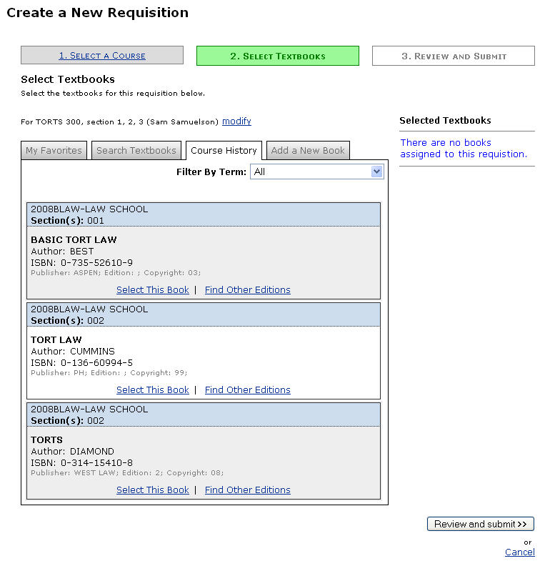

- To add a title to the requisition, click the Select This Book link (Fig. 77).

- Set the book parameters for the title you selected (Fig. 78).

Figure 2: Book Parameters
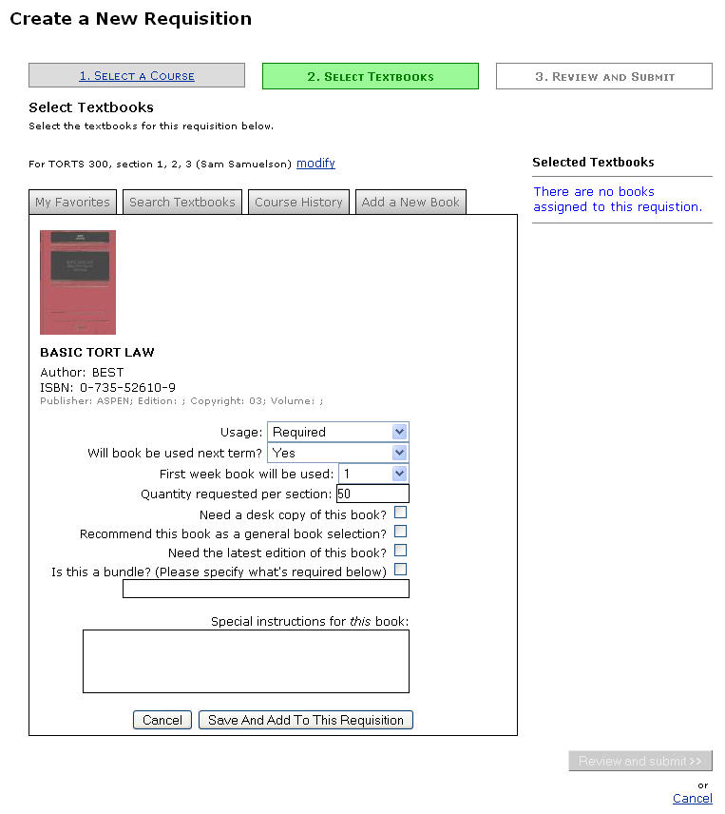

- Click the Save and Add to This Requisition button. The title will display beneath the Selected Textbooks header on the right side of the screen (Fig. 79).

Figure 3: Title Added to Requisition
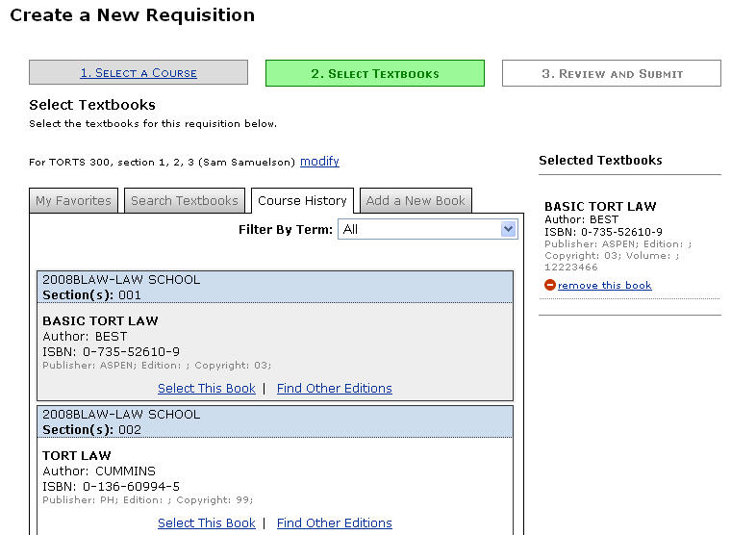

- You can add other books using course history or add titles using other available methods (book favorites, search, and manual addition) until all necessary titles have been added to the requisition. Click the Review and Submit button when you are finished.

To add textbooks using your book favorites:

- Click the My Favorites link. (The screen may automatically open to this option if you have books saved as favorites.)

- To add a title to the requisition, click the Select This Book link (Fig. 80).

Figure 4: Book Favorites
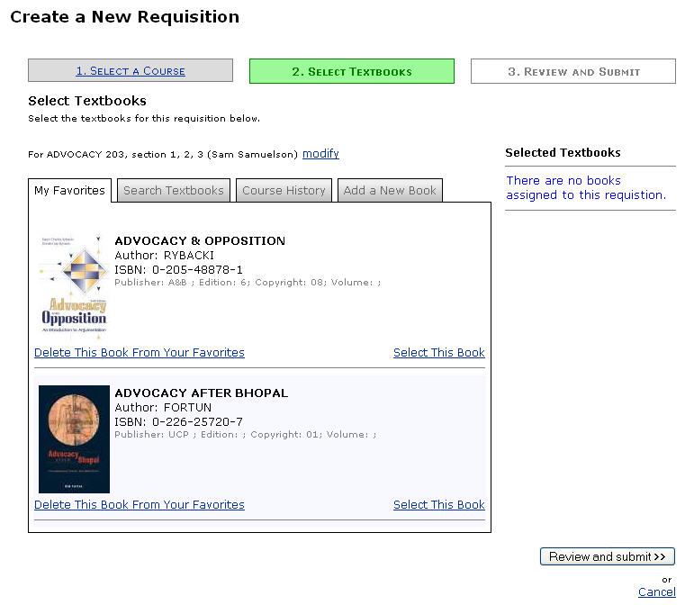

- Set the book parameters for the title you selected (Fig. 81).

Figure 5: Book Parameters
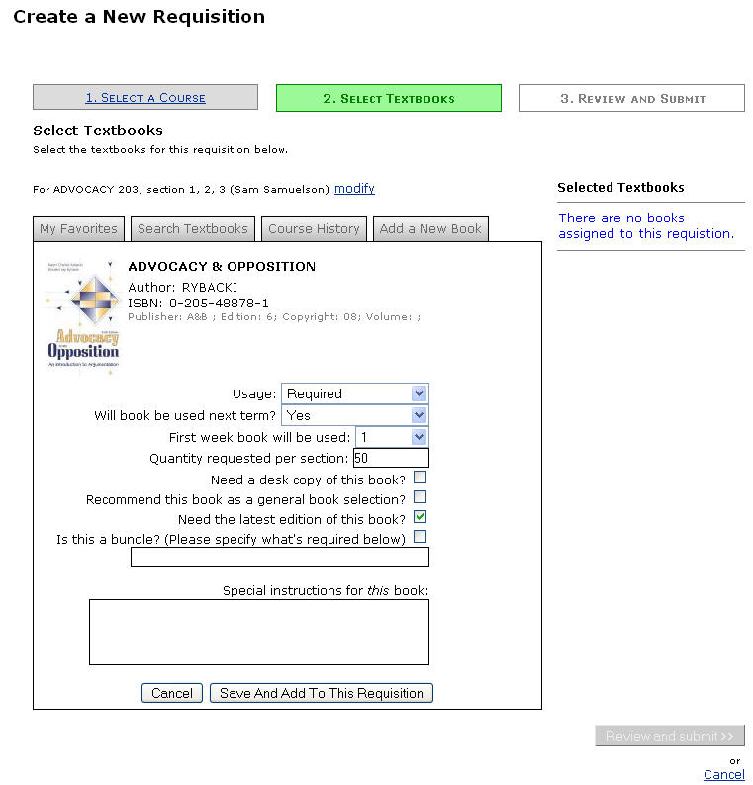

- Click the Save and Add to This Requisition button.

- A message will display beneath the title in the search results to note that it has been added to the requisition. The title will also display beneath the Selected Textbooks header on the right side of the screen (Fig. 82).

Figure 6: Title Added to Requisition
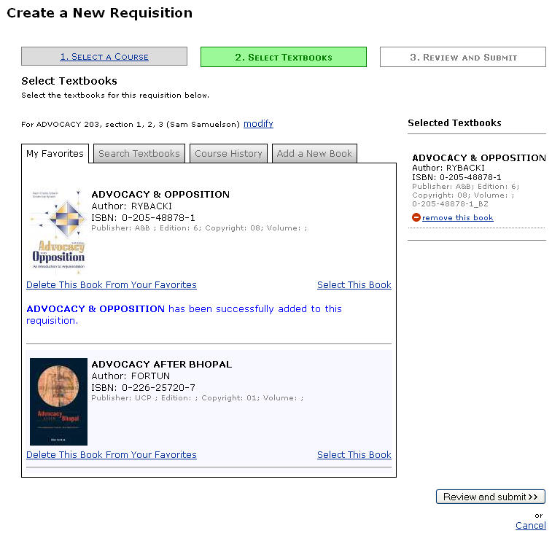

- You can add other books from your favorites or add titles using other available methods (search, course history, and manual addition) until all necessary titles have been added to the requisition. Click the Review and Submit button when you are finished.

To add textbooks manually:

- Click the Add a New Book link.

- Fill in the fields to add a textbook manually. You must enter at least the title, author, and ISBN (unless you check the “ISBN unknown” box) (Fig. 83).

Figure 7: Enter a Textbook Manually
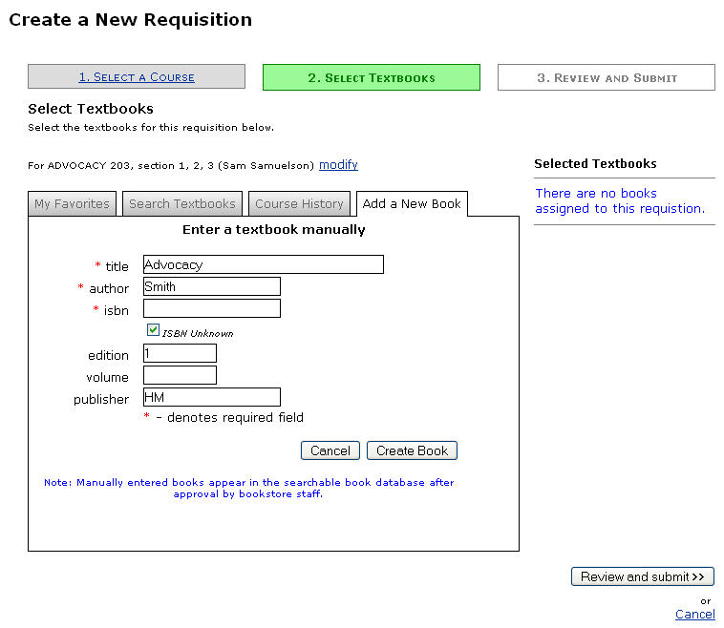

- Click the Create Book button (Fig. 83).

- Set the book parameters for the title you selected (Fig. 84).

Figure 8: Book Parameters
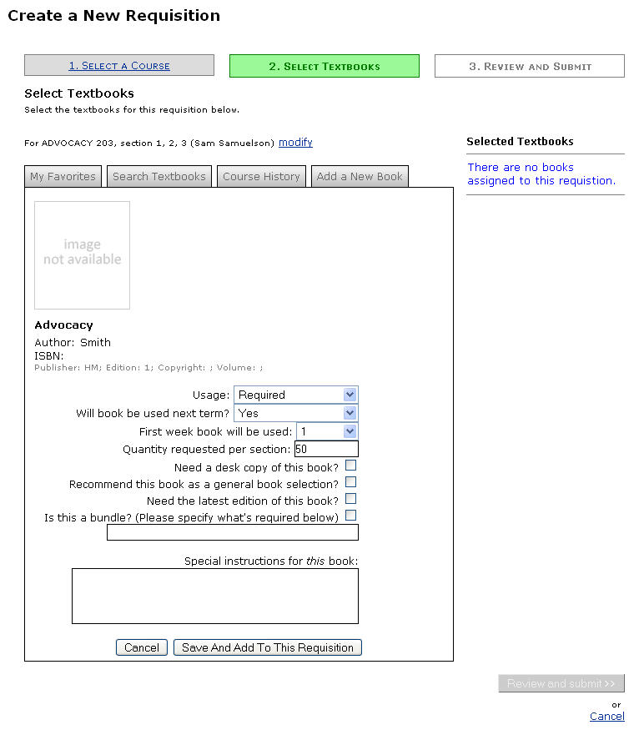

- Click the Save and Add to This Requisition button.

- The title will display beneath the Selected Textbooks header on the right side of the screen (Fig. 85). If you entered an ISBN that already exists in the book database, though, you’ll get a message asking you to select the existing book record or cancel.

Figure 9: Book Manually Added to Requisition
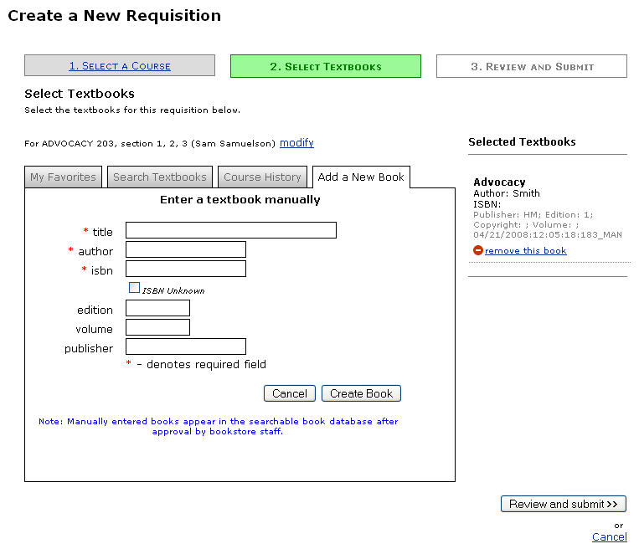

- You can add other books manually or add titles using other available methods (favorites, search, and course history) until all necessary titles have been added to the requisition. Click the Review and Submit button when you are finished.

(Back to Adding Textbooks to a Requisition)

- Review the requisition to make sure all information and textbook selections are correct.

- If you want to save the requisition but you are not ready to submit it to the bookstore, click the Save button. If you are ready to submit the requisition to the bookstore, click the Save and Submit button (Fig. 86).

Figure 10: Review Requisition
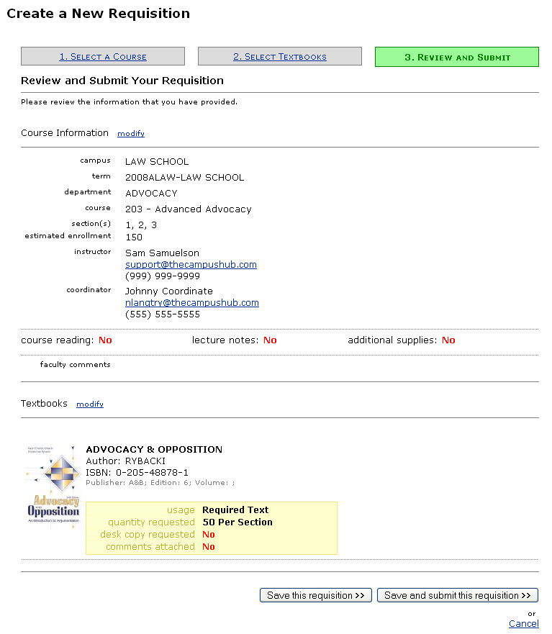

- If you save the requisition, you can modify it until you are ready to submit it. It will appear on your home page in the Textbook Requisitions system. If you submit the requisition, it will also appear on your home page, but you may not be able to edit it . Both the “save” and “submit” screens will allow you to create a new requisition based on the current requisition and to print the current requisition (Fig. 87).

Figure 11: Requisition Details
